STEM HS Course Pathway
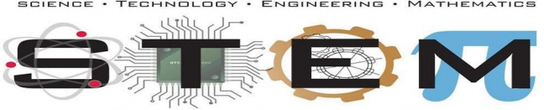
 | SCIENCE |  | TECHNOLOGY | ENGINEERING | MANUFACTURING | MATH
 | Advanced Science  5 CREDITS | Biomedical Science  4 CREDITS | 4 CREDITS  (PLUS 1 upper level math course) | 4 CREDITS | 4 CREDITS | 5 CREDITS
9th Grade | ❏ H3233L Biology Honors* | ❏ H8342L Biotechnology  (Industry-Based Certification) | ❏ H3032L Principles of Comp Science  (May have been taken in 8th grade) | ❏ H8250L Principles of Applied Engineering  (May have been taken in 8th grade) | ❏ H8250L Principles of Applied Engineering  (May have been taken in 8th grade) | ❏ H2313L Algebra I  (May have been taken in 8th grade)
10th  Grade | ❏ H3333L Chem Honors* | ❏ H6758L Medical Microbiology+ | ❏ H3005 Comp Sci I Honors  (Industry-Based Certification) | ❏ H8252L Engineering Design & Pres I  (Industry-Based Certification) | ❏ H8094L Robotics I | ❏ H2414L Geometry Honors
11th  Grade | ❏ H3444L AP Physics* | ❏H6759L Pathophysiology | ❏ H3006L Comp Sci II Honors | ❏ H8258L Engineering Design Prob Solving✛ | ❏ H6768L Robotics II#  (Industry-Based Certification) | ❏ H2324L Algebra II Honors
12th  Grade | And two of the following advanced courses:  ❏ H3252L Anat & Phys  ❏ H3243L AP Biology  ❏ H3743L AP Environ Sci  ❏H3228L Organic Chem /  H3343L AP Chemistry^  ❏ H3445L AP Physics II | ❏ H8260L Practicum in STEM (Internship) | ❏ H3027L Computer Science III  (Industry-Based Certification)  ❏ H8260L Practicum in STEM (Internship) | ❏ H8259L Scientific Research and Design  ❏ H8260L Practicum in STEM (Internship)  (Industry-Based Certification) | ❏ H8312L Practicum in Entrepreneurship (Internship) | ❏ H2728L AP Pre-Calculus
And one of the following upper level math courses:
❏ H2947L AP Statistics
❏ H2734L AP Calc AB
❏ H2735L AP Calc BC
❏ H8251L Eng Math
Other Upper Level Elective Options: H4130L 11th Grade - AP Seminar H4131L 12th Grade - AP Research (AP Seminar - Prerequisite)
* Required Grade Level Course # Counts as a Math Credit ✛ Counts as a Science Credit ^ Courses offered in alternating years - see STEM Counselor for more information
Rev. 01.11.2023

